**DN 4.0 JAVA FSE SOLUTIONS – WEEK 4**

**SKILL: Spring REST using Spring Boot 3**

**HandsOn 1.Create a Spring Web Project using Maven**

After extracting and importing the zip file (spring-learn.zip) into the workspace

**src/main/java/com/cognizant/springlearn/SpringLearnApplication.java -**

package com.cognizant.springlearn;

import org.springframework.boot.SpringApplication;

import org.springframework.boot.autoconfigure.SpringBootApplication;

import org.slf4j.Logger;

import org.slf4j.LoggerFactory;

@SpringBootApplication

public class SpringLearnApplication {

private static final Logger LOGGER = LoggerFactory.getLogger(SpringLearnApplication.class);

public static void main(String[] args) {

SpringApplication.run(SpringLearnApplication.class, args);

LOGGER.info("Inside main method - Application Started Successfully");

}

}

**pom.xml -**

<?xml version="1.0" encoding="UTF-8"?>  
<project xmlns="http://maven.apache.org/POM/4.0.0"  
 xmlns:xsi="http://www.w3.org/2001/XMLSchema-instance"  
 xsi:schemaLocation="http://maven.apache.org/POM/4.0.0 http://maven.apache.org/xsd/maven-4.0.0.xsd">  
 <modelVersion>4.0.0</modelVersion>  
  
 <groupId>com.cognizant</groupId>  
 <artifactId>spring-learn</artifactId>  
 <version>1.0-SNAPSHOT</version>  
  
 <parent>  
 <groupId>org.springframework.boot</groupId>  
 <artifactId>spring-boot-starter-parent</artifactId>  
 <version>3.2.0</version>  
 <relativePath/> <!-- lookup parent from repository -->  
 </parent>  
 <properties>  
 <maven.compiler.source>21</maven.compiler.source>  
 <maven.compiler.target>21</maven.compiler.target>  
 <project.build.sourceEncoding>UTF-8</project.build.sourceEncoding>  
 </properties>  
  
 <dependencies>  
 <dependency>  
 <groupId>org.springframework.boot</groupId>  
 <artifactId>spring-boot-starter-web</artifactId>  
 </dependency>  
 <dependency>  
 <groupId>org.springframework.boot</groupId>  
 <artifactId>spring-boot-devtools</artifactId>  
 <scope>runtime</scope>  
 </dependency>  
 <dependency>  
 <groupId>org.springframework.boot</groupId>  
 <artifactId>spring-boot-starter-test</artifactId>  
 <scope>test</scope>  
 </dependency>  
 </dependencies>  
  
 <build>  
 <plugins>  
 <plugin>  
 <groupId>org.springframework.boot</groupId>  
 <artifactId>spring-boot-maven-plugin</artifactId>  
 </plugin>  
 </plugins>  
 </build>  
</project>

**Output:**

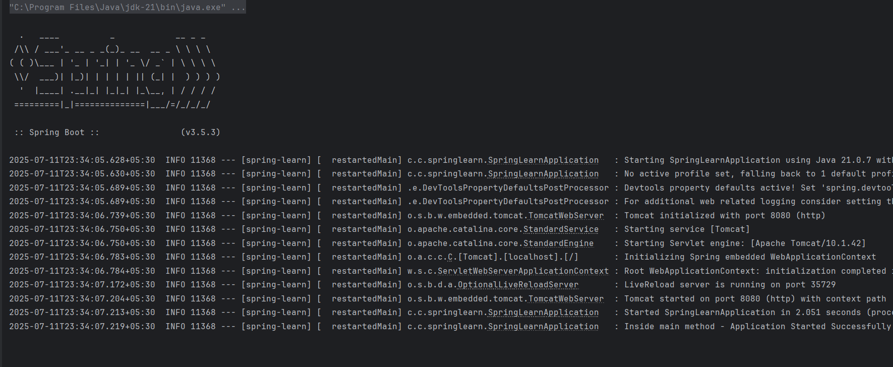

**HandsOn 2 . Spring Core – Load Country from Spring Configuration XML**

**src/main/java/com/cognizant/springlearn/SpringLearnApplication.java -**

package com.cognizant.springlearn;  
  
import com.cognizant.springlearn.model.Country;  
import org.slf4j.Logger;  
import org.slf4j.LoggerFactory;  
import org.springframework.boot.CommandLineRunner;  
import org.springframework.boot.SpringApplication;  
import org.springframework.boot.autoconfigure.SpringBootApplication;  
import org.springframework.context.ApplicationContext;  
import org.springframework.context.support.ClassPathXmlApplicationContext;  
  
@SpringBootApplication  
public class SpringLearnApplication implements CommandLineRunner {  
  
 private static final Logger *LOGGER* = LoggerFactory.*getLogger*(SpringLearnApplication.class);  
  
 public static void main(String[] args) {  
 SpringApplication.*run*(SpringLearnApplication.class, args);  
 }  
  
 // This method will run after the Spring Boot application starts  
 @Override  
 public void run(String... args) throws Exception {  
 *LOGGER*.info("START");  
 displayCountry();  
 *LOGGER*.info("END");  
 }  
  
 public void displayCountry() {  
 try {  
 ApplicationContext context = new ClassPathXmlApplicationContext("country.xml");  
 Country country = context.getBean("country", Country.class);  
 *LOGGER*.debug("Country : {}", country.toString());  
 } catch (Exception e) {  
 *LOGGER*.error("Error occurred while loading country bean: ", e);  
 }  
 }  
}

**application.properties**

logging.level.com.cognizant.springlearn=DEBUG

**src/main/java/com/cognizant/springlearn/Country.java -**

package com.cognizant.springlearn.model;  
  
import org.slf4j.Logger;  
import org.slf4j.LoggerFactory;  
  
public class Country {  
  
 private static final Logger *LOGGER* = LoggerFactory.*getLogger*(Country.class);  
  
 private String code;  
 private String name;  
  
 public Country() {  
 *LOGGER*.debug("Inside Country Constructor.");  
 }  
  
 public String getCode() {  
 *LOGGER*.debug("Inside getCode()");  
 return code;  
 }  
  
 public void setCode(String code) {  
 *LOGGER*.debug("Inside setCode()");  
 this.code = code;  
 }  
  
 public String getName() {  
 *LOGGER*.debug("Inside getName()");  
 return name;  
 }  
  
 public void setName(String name) {  
 *LOGGER*.debug("Inside setName()");  
 this.name = name;  
 }  
  
 @Override  
 public String toString() {  
 return "Country{code='" + code + "', name='" + name + "'}";  
 }  
}

**src/main/resources/country.xml -**

<?xml version="1.0" encoding="UTF-8"?>  
<beans xmlns="http://www.springframework.org/schema/beans"  
 xmlns:xsi="http://www.w3.org/2001/XMLSchema-instance"  
 xsi:schemaLocation="  
 http://www.springframework.org/schema/beans  
 https://www.springframework.org/schema/beans/spring-beans.xsd">  
  
 <bean id="country" class="com.cognizant.springlearn.model.Country">  
 <property name="code" value="IN"/>  
 <property name="name" value="India"/>  
 </bean>  
  
</beans>

**Output:**

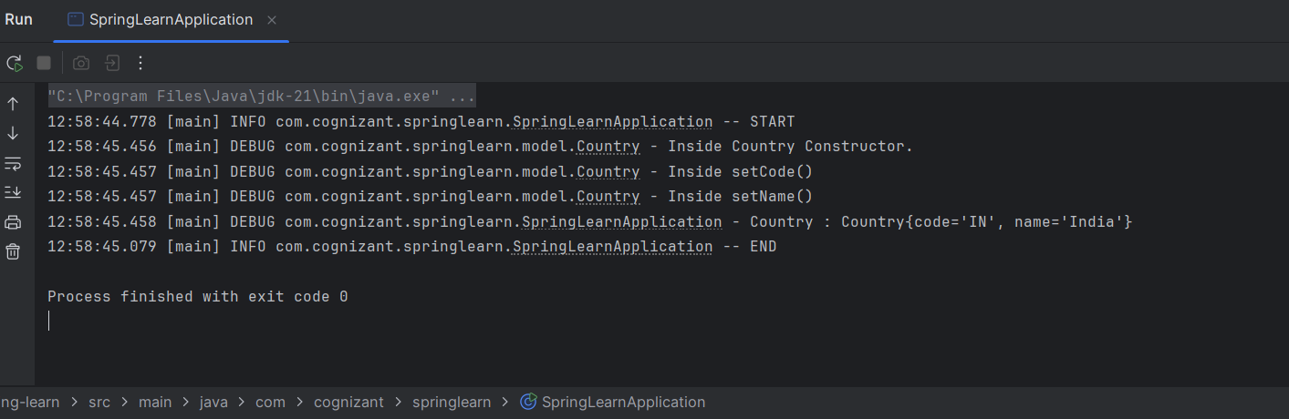

**HandsOn 3.Hello World RESTful Web Service**

**src/main/java/com/cognizant/springlearn/SpringLearnApplication.java**

package com.cognizant.springlearn;  
import com.cognizant.springlearn.model.Country;  
import org.slf4j.Logger;  
import org.slf4j.LoggerFactory;  
import org.springframework.boot.CommandLineRunner;  
import org.springframework.boot.SpringApplication;  
import org.springframework.boot.autoconfigure.SpringBootApplication;  
import org.springframework.context.ApplicationContext;  
import org.springframework.context.support.ClassPathXmlApplicationContext;  
  
@SpringBootApplication  
public class SpringLearnApplication {  
  
 private static final Logger *LOGGER* = LoggerFactory.*getLogger*(SpringLearnApplication.class);  
  
 public static void main(String[] args) {  
 *LOGGER*.info("START");  
 SpringApplication.*run*(SpringLearnApplication.class, args);  
 *LOGGER*.info("END");  
 }  
}

**src/main/java/com/cognizant/springlearn/controller/HelloController.java** package com.cognizant.springlearn.controller;  
import org.slf4j.Logger;  
import org.slf4j.LoggerFactory;  
import org.springframework.web.bind.annotation.GetMapping;  
import org.springframework.web.bind.annotation.RestController;  
  
@RestController  
public class HelloController {  
  
 private static final Logger *LOGGER* = LoggerFactory.*getLogger*(HelloController.class);  
  
 @GetMapping("/hello")  
 public String sayHello() {  
 *LOGGER*.info("START - sayHello()");  
 String response = "Hello World!!";  
 *LOGGER*.info("END - sayHello()");  
 return response;  
 }  
}

**application.properties**

server.port=8083  
logging.level.com.cognizant.springlearn=DEBUG

**src/main/resources/country.xml**

<?xml version="1.0" encoding="UTF-8"?>  
<beans xmlns="http://www.springframework.org/schema/beans"  
 xmlns:xsi="http://www.w3.org/2001/XMLSchema-instance"  
 xsi:schemaLocation="  
 http://www.springframework.org/schema/beans  
 https://www.springframework.org/schema/beans/spring-beans.xsd">  
  
 <bean id="country" class="com.cognizant.springlearn.model.Country">  
 <property name="code" value="IN"/>  
 <property name="name" value="India"/>  
 </bean>  
</beans>

**Output:**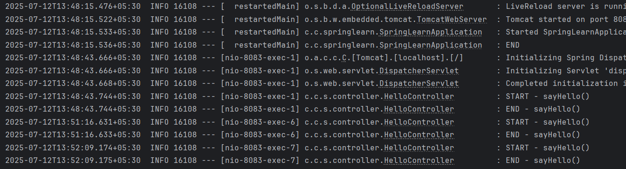

In Postman

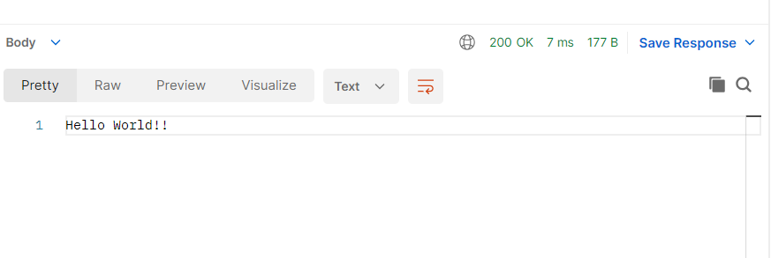

**HandsOn 4.REST - Country Web Service**

**src/main/java/com/cognizant/springlearn/SpringLearnApplication.java** package com.cognizant.springlearn;  
  
import com.cognizant.springlearn.model.Country;  
import org.slf4j.Logger;  
import org.slf4j.LoggerFactory;  
import org.springframework.boot.CommandLineRunner;  
import org.springframework.boot.SpringApplication;  
import org.springframework.boot.autoconfigure.SpringBootApplication;  
import org.springframework.context.ApplicationContext;  
import org.springframework.context.support.ClassPathXmlApplicationContext;  
  
@SpringBootApplication  
public class SpringLearnApplication implements CommandLineRunner {  
  
 private static final Logger *LOGGER* = LoggerFactory.*getLogger*(SpringLearnApplication.class);  
  
 public static void main(String[] args) {  
 *LOGGER*.info("START");  
 SpringApplication.*run*(SpringLearnApplication.class, args);  
 *LOGGER*.info("END"); // This will still print immediately after Spring context starts  
 }  
  
 @Override  
 public void run(String... args) throws Exception {  
 displayCountry();  
 }  
  
 public void displayCountry() {  
 ApplicationContext context = new ClassPathXmlApplicationContext("country.xml");  
 Country country = context.getBean("country", Country.class);  
 *LOGGER*.debug("Country : {}", country.toString());  
 }  
}

**src/main/resources/application.properties -**

server.port=8083

**src/main/java/com/cognizant/springlearn/controller/CountryController.java** package com.cognizant.springlearn.controller;  
import com.cognizant.springlearn.model.Country;  
import org.slf4j.Logger;  
import org.slf4j.LoggerFactory;  
import org.springframework.context.ApplicationContext;  
import org.springframework.context.support.ClassPathXmlApplicationContext;  
import org.springframework.web.bind.annotation.RequestMapping;  
import org.springframework.web.bind.annotation.RestController;  
  
@RestController  
public class CountryController {  
  
 private static final Logger *LOGGER* = LoggerFactory.*getLogger*(CountryController.class);  
  
 @RequestMapping("/country")  
 public Country getCountryIndia() {  
 *LOGGER*.info("START - getCountryIndia()");  
  
 ApplicationContext context = new ClassPathXmlApplicationContext("country.xml");  
 Country country = context.getBean("country", Country.class);  
  
 *LOGGER*.debug("Country: {}", country);  
 *LOGGER*.info("END - getCountryIndia()");  
 return country;  
 }  
}

**src/main/java/com/cognizant/springlearn/Country.java**

package com.cognizant.springlearn.model;  
  
import org.slf4j.Logger;  
import org.slf4j.LoggerFactory;  
  
public class Country {  
  
 private static final Logger *LOGGER* = LoggerFactory.*getLogger*(Country.class);  
  
 private String code;  
 private String name;  
  
 public Country() {  
 *LOGGER*.debug("Inside Country Constructor.");  
 }  
  
 public String getCode() {  
 *LOGGER*.debug("Inside getCode()");  
 return code;  
 }  
  
 public void setCode(String code) {  
 *LOGGER*.debug("Inside setCode()");  
 this.code = code;  
 }  
  
 public String getName() {  
 *LOGGER*.debug("Inside getName()");  
 return name;  
 }  
  
 public void setName(String name) {  
 *LOGGER*.debug("Inside setName()");  
 this.name = name;  
 }  
  
 @Override  
 public String toString() {  
 return "Country{" +  
 "code='" + code + '\'' +  
 ", name='" + name + '\'' +  
 '}';  
 }  
}

**src/main/resources/country.xml -**

<?xml version="1.0" encoding="UTF-8"?>

<beans xmlns="http://www.springframework.org/schema/beans"

xmlns:xsi="http://www.w3.org/2001/XMLSchema-instance"

xsi:schemaLocation="

http://www.springframework.org/schema/beans

http://www.springframework.org/schema/beans/spring-beans.xsd">

<bean id="country" class="com.cognizant.springlearn.Country">

<property name="code" value="IN" />

<property name="name" value="India" />

</bean>

</beans>

**output:**

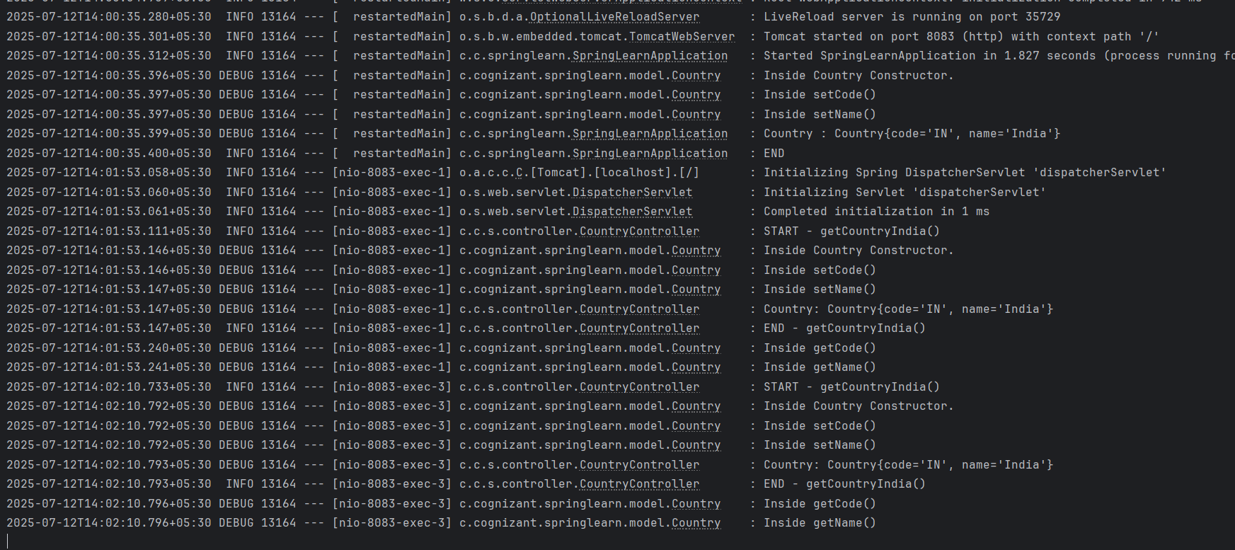

In postman

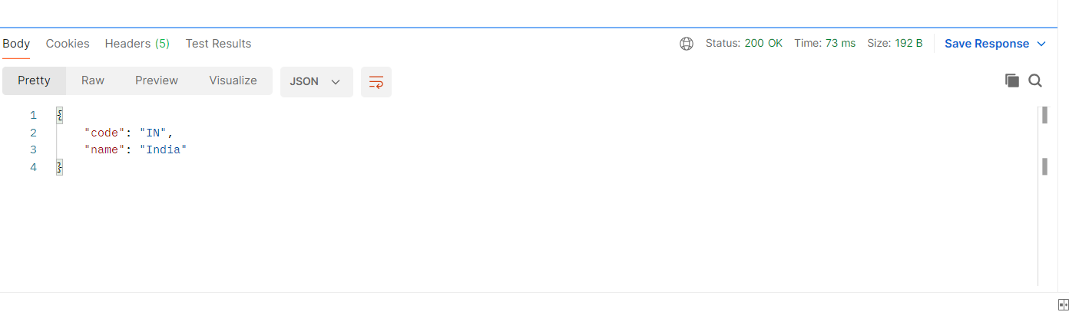

**HandsOn 5.REST - Get country based on country code**

**src/main/java/com/cognizant/springlearn/controller/CountryController.java**

package com.cognizant.springlearn.controller;

import com.cognizant.springlearn.model.Country;

import com.cognizant.springlearn.service.CountryService;

import org.springframework.beans.factory.annotation.Autowired;

import org.springframework.web.bind.annotation.*;

@RestController

public class CountryController {

@Autowired

private CountryService countryService;

@GetMapping("/countries/{code}")

public Country getCountry(@PathVariable String code) throws Exception {

return countryService.getCountry(code);

}

}

**src/main/java/com/cognizant/springlearn/service/CountryService.java**

package com.cognizant.springlearn.service;

import com.cognizant.springlearn.model.Country;

import org.springframework.context.ApplicationContext;

import org.springframework.context.support.ClassPathXmlApplicationContext;

import org.springframework.stereotype.Service;

import java.util.List

@Service

public class CountryService {

public Country getCountry(String code) throws Exception {

ApplicationContext context = new ClassPathXmlApplicationContext("country.xml");

List<Country> countryList = (List<Country>) context.getBean("countryList");

return countryList.stream()

.filter(c -> c.getCode().equalsIgnoreCase(code))

.findFirst()

.orElseThrow(() -> new Exception("Country not found with code: " + code));

}

}

**src/main/resources/country.xml -**

<?xml version="1.0" encoding="UTF-8"?>

<beans xmlns="http://www.springframework.org/schema/beans"

xmlns:xsi="http://www.w3.org/2001/XMLSchema-instance"

xsi:schemaLocation="

http://www.springframework.org/schema/beans

https://www.springframework.org/schema/beans/spring-beans.xsd">

<bean id="country" class="com.cognizant.springlearn.model.Country">

<property name="code" value="IN"/>

<property name="name" value="India"/>

</bean>

<bean id="countryList" class="java.util.ArrayList">

<constructor-arg>

<list>

<bean class="com.cognizant.springlearn.model.Country">

<property name="code" value="IN"/>

<property name="name" value="India"/>

</bean>

<bean class="com.cognizant.springlearn.model.Country">

<property name="code" value="US"/>

<property name="name" value="United States"/>

</bean>

<bean class="com.cognizant.springlearn.model.Country">

<property name="code" value="JP"/>

<property name="name" value="Japan"/>

</bean>

</list>

</constructor-arg>

</bean>

</beans>

**src/main/java/com/cognizant/springlearn/Country.java-**

package com.cognizant.springlearn;

public class Country {

private String code;

private String name;

public Country() {}

public String getCode() {

return code;

}

public void setCode(String code) {

this.code = code;

}

public String getName() {

return name;

}

public void setName(String name) {

this.name = name;

}}

**src/main/java/com/cognizant/springlearn/SpringLearnApplication.java**

package com.cognizant.springlearn;

import org.springframework.boot.SpringApplication;

import org.springframework.boot.autoconfigure.SpringBootApplication;

@SpringBootApplication

public class SpringLearnApplication {

public static void main(String[] args) {

SpringApplication.run(SpringLearnApplication.class, args);

}}

**Output:**

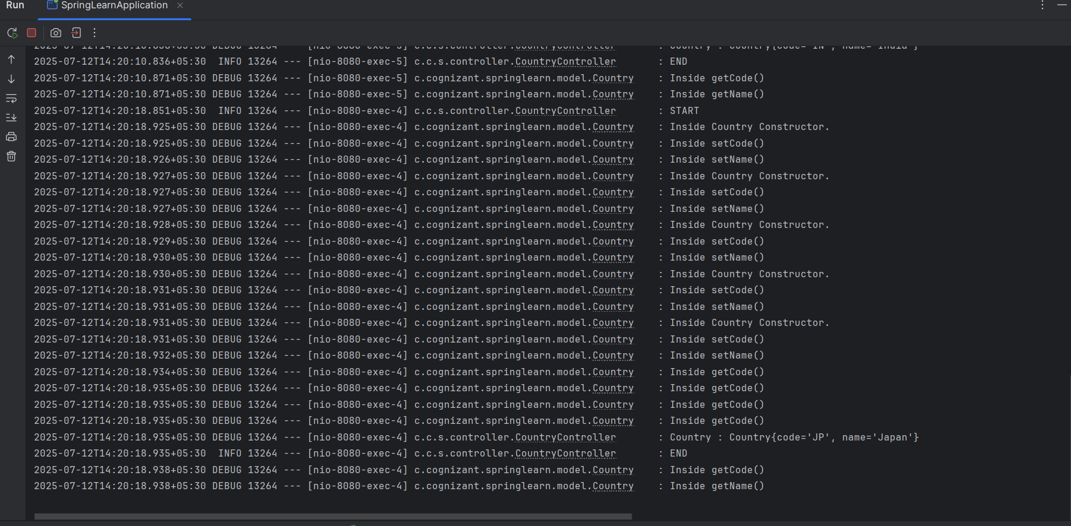

In postman

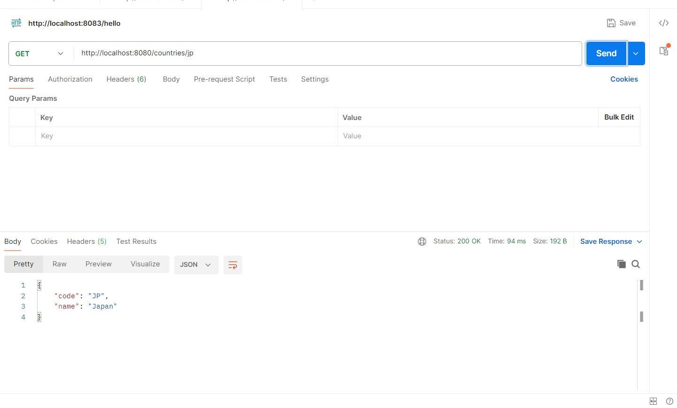

**Hand On 6.Create authentication service that returns JWT**

**src/main/java/com/cognizant/springlearn/SpringLearnApplication.java -**

package com.cognizant.springlearn;  
  
import org.slf4j.Logger;  
import org.slf4j.LoggerFactory;  
import org.springframework.boot.SpringApplication;  
import org.springframework.boot.autoconfigure.SpringBootApplication;  
  
@SpringBootApplication  
public class SpringLearnApplication {  
  
 private static final Logger *LOGGER* = LoggerFactory.*getLogger*(SpringLearnApplication.class);  
  
 public static void main(String[] args) {  
 *LOGGER*.info("START");  
 SpringApplication.*run*(SpringLearnApplication.class, args);  
 *LOGGER*.info("END");  
 }  
}

**JwtUtil.java**

package com.cognizant.springlearn.util;  
  
import io.jsonwebtoken.*;  
import io.jsonwebtoken.security.Keys;  
import org.springframework.stereotype.Component;  
  
import javax.crypto.SecretKey;  
import java.util.Date;  
  
@Component  
public class JwtUtil {  
 private final SecretKey key = Keys.*secretKeyFor*(SignatureAlgorithm.*HS256*);  
  
 public String generateToken(String username) {  
 return Jwts.*builder*()  
 .setSubject(username)  
 .setIssuedAt(new Date(System.*currentTimeMillis*()))  
 .setExpiration(new Date(System.*currentTimeMillis*() + 60 * 60 * 1000)) // 1 hour  
 .signWith(key)  
 .compact();  
 }  
}

**src/main/java/com/cognizant/springlearn/SecurityConfig.java -**

package com.cognizant.springlearn.config;  
  
import org.springframework.context.annotation.Bean;  
import org.springframework.context.annotation.Configuration;  
import org.springframework.security.config.annotation.web.configuration.EnableWebSecurity;  
import org.springframework.security.config.annotation.web.builders.HttpSecurity;  
import org.springframework.security.web.SecurityFilterChain;  
import org.springframework.security.config.Customizer;  
  
@Configuration  
@EnableWebSecurity  
public class SecurityConfig {  
  
 @Bean  
 public SecurityFilterChain filterChain(HttpSecurity http) throws Exception {  
 http.csrf(csrf -> csrf.disable())  
 .authorizeHttpRequests(auth -> auth  
 .requestMatchers("/authenticate").permitAll()  
 .anyRequest().authenticated()  
 )  
 .httpBasic(Customizer.*withDefaults*()); // Enable basic auth  
 return http.build();  
 }  
}

**src/main/java/com/cognizant/springlearn/controller/AuthenticationController.java –**

package com.cognizant.springlearn.controller;

import com.cognizant.springlearn.util.JwtUtil;

import org.springframework.beans.factory.annotation.Autowired;

import org.springframework.http.ResponseEntity;

import org.springframework.web.bind.annotation.*;

import java.util.Base64;

@RestController

public class AuthenticationController {

@Autowired

private JwtUtil jwtUtil;

@GetMapping("/authenticate")

public ResponseEntity<?> authenticate(@RequestHeader("Authorization") String authHeader) {

if (authHeader == null || !authHeader.startsWith("Basic ")) {

return ResponseEntity.status(401).body("Missing or invalid Authorization header");

}

String base64Credentials = authHeader.substring("Basic ".length()).trim();

byte[] credDecoded = Base64.getDecoder().decode(base64Credentials);

String credentials = new String(credDecoded);

String[] values = credentials.split(":", 2);

String username = values[0];

String password = values[1];

// Hardcoded auth check

if ("user".equals(username) && "pwd".equals(password)) {

String token = jwtUtil.generateToken(username);

return ResponseEntity.ok().body("{\"token\": \"" + token + "\"}");

} else {

return ResponseEntity.status(401).body("Invalid credentials");

}

}}

**Dependencies in pom.xml -**

<dependencies>  
 <dependency>  
 <groupId>org.springframework.boot</groupId>  
 <artifactId>spring-boot-starter-web</artifactId>  
 </dependency>  
 <dependency>  
 <groupId>org.springframework.boot</groupId>  
 <artifactId>spring-boot-devtools</artifactId>  
 <scope>runtime</scope>  
 <optional>true</optional>  
 </dependency>  
 <dependency>  
 <groupId>org.springframework.boot</groupId>  
 <artifactId>spring-boot-starter-test</artifactId>  
 <scope>test</scope>  
 </dependency>  
 <dependency>  
 <groupId>io.jsonwebtoken</groupId>  
 <artifactId>jjwt</artifactId>  
 <version>0.9.0</version>  
 </dependency>  
 <dependency>  
 <groupId>org.springframework.boot</groupId>  
 <artifactId>spring-boot-starter-security</artifactId>  
 </dependency>  
 <!-- For Java 11+ -->  
 <dependency>  
 <groupId>javax.xml.bind</groupId>  
 <artifactId>jaxb-api</artifactId>  
 <version>2.3.1</version>  
 </dependency>  
</dependencies>

**application.properties -**

server.port=8090

**output:**

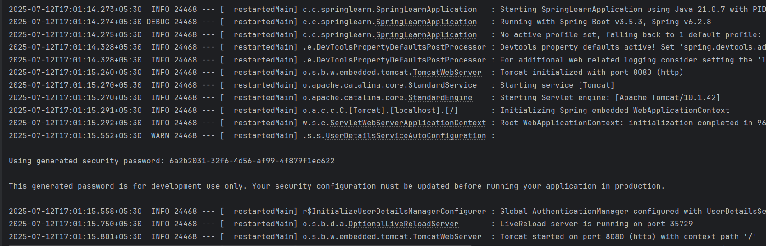

**In Browser**

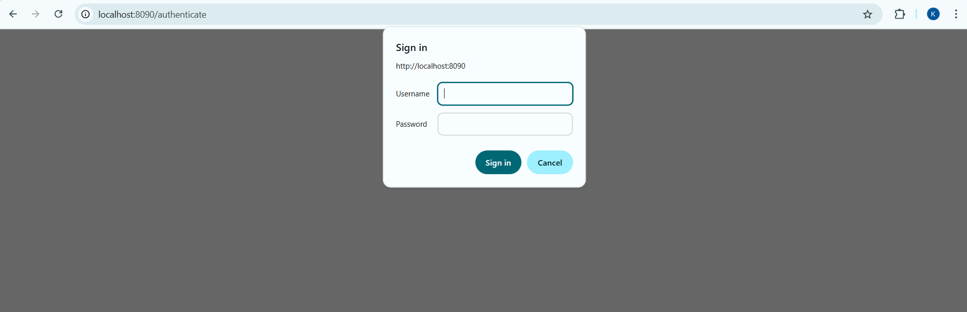

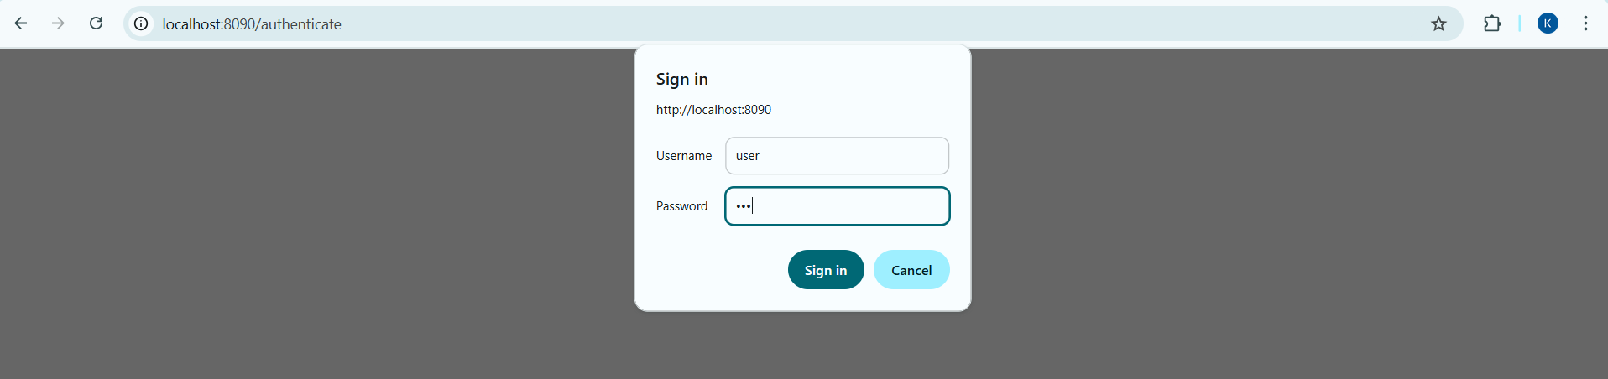

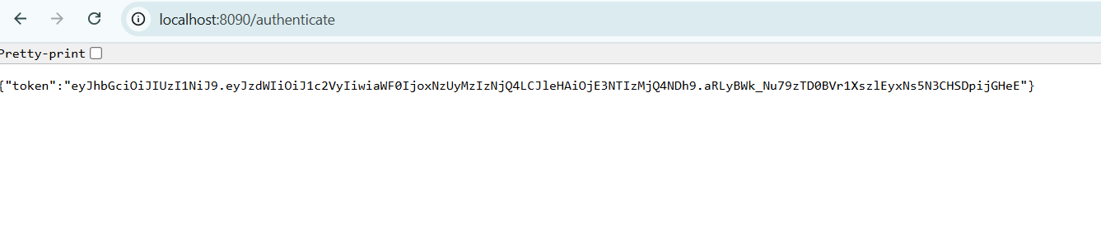

**In postman  
